Для печати

Welcome to

KaSBariMeT-2018

Ι-th Kazakhstan International Congress on Bariatric and Metabolic Surgery. July 4-5, 2018. Astana, Kazakhstan

  - The congress highlights the theme: «Bariatric surgery in the treatment of metabolic syndrome (diabetes mellitus, non-alcoholic fatty liver disease, dyslipidemia, hypertensive disease and obesity"

The Congress was included in the plan of scientific and practical measures of the Ministry of Health of the Republic of Kazakhstan for 2018 and coordinated with the vice-minister of health of the Republic of Kazakhstan L. Aktaeva on January 8, 2018.
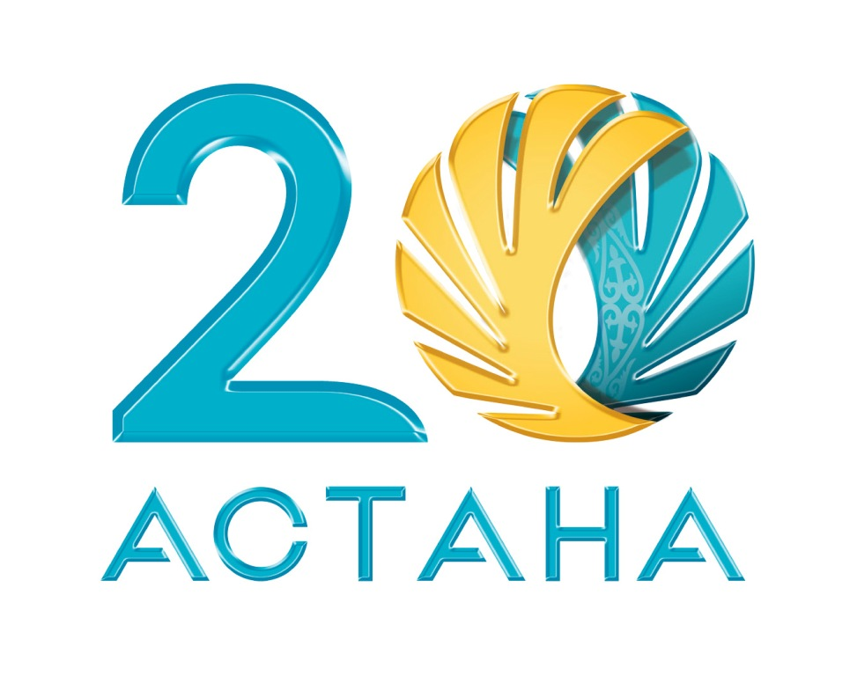The Congress is dedicated to the 20th anniversary of Astana
capital city of Kazakhstan

Organizers of Congress

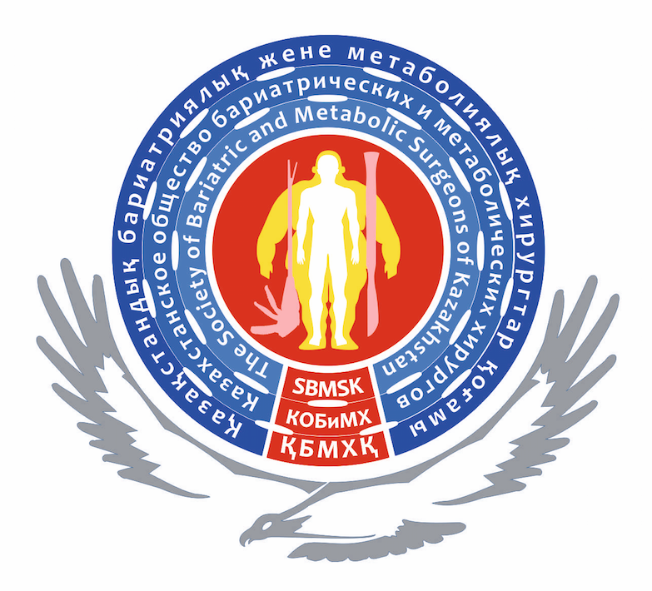 Society of Bariatric and Metabolic Surgeons of Kazakhstan

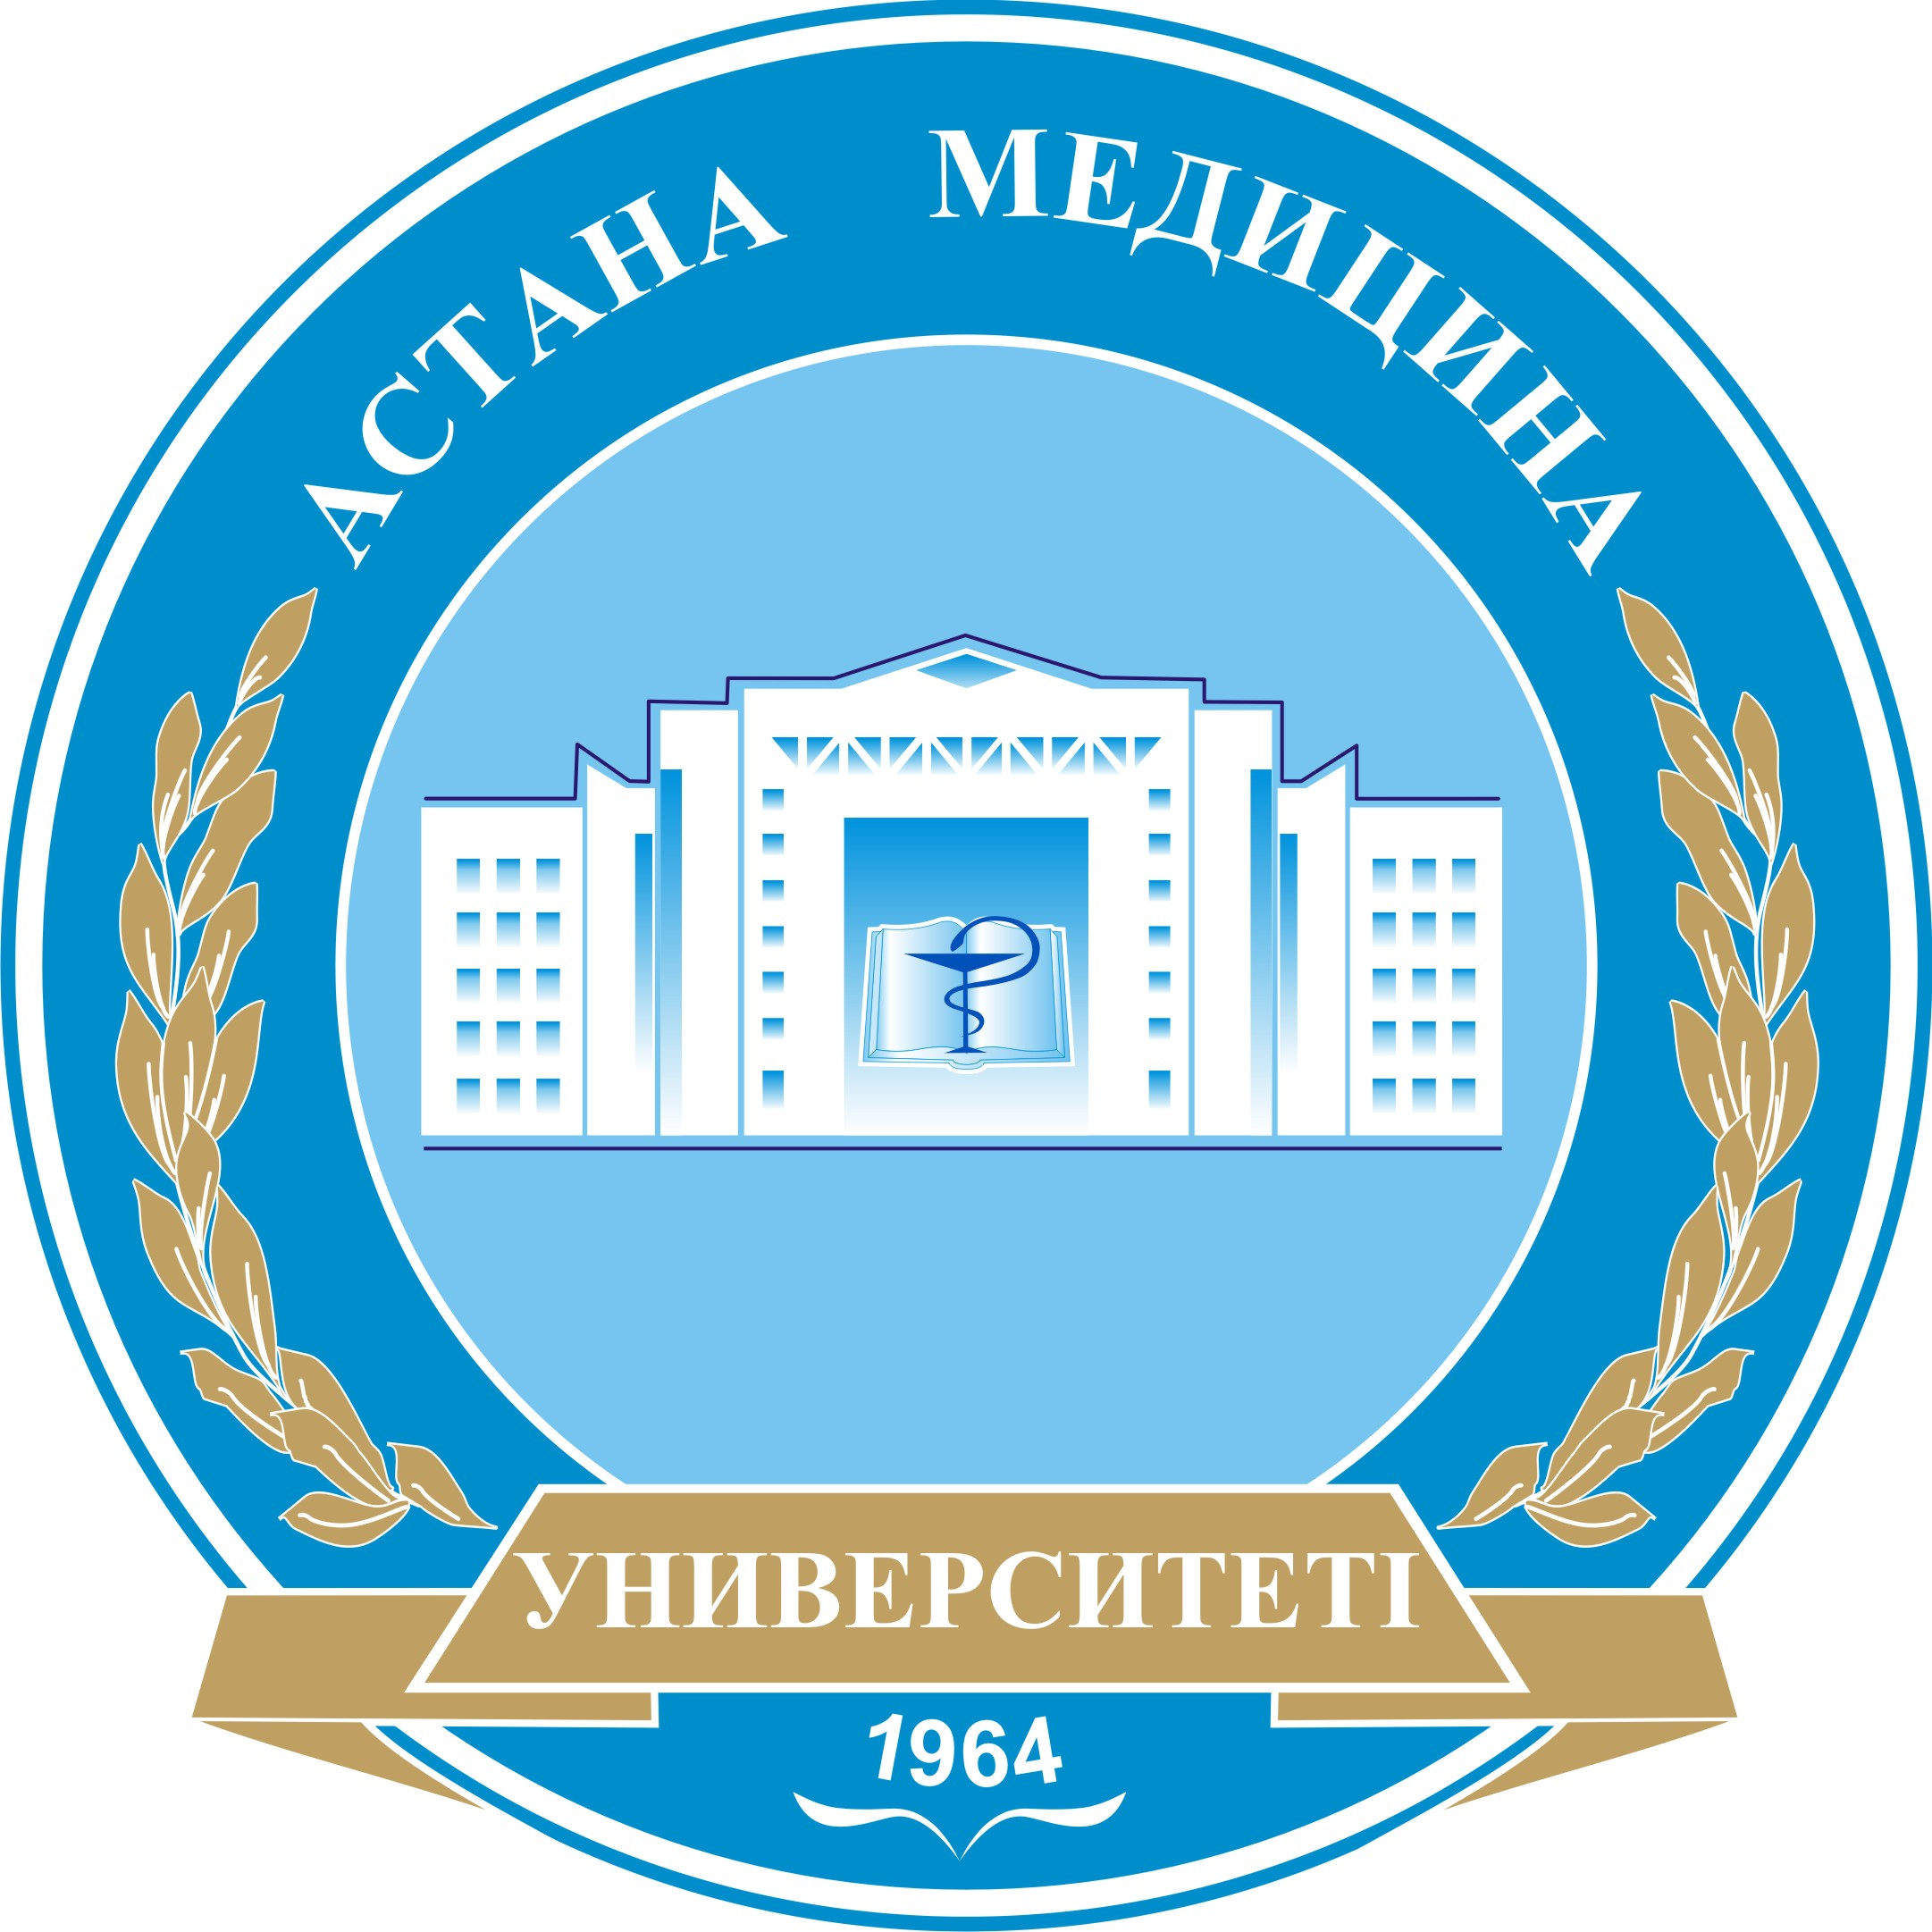 Astana Medical University

Supporting Organization of Congress

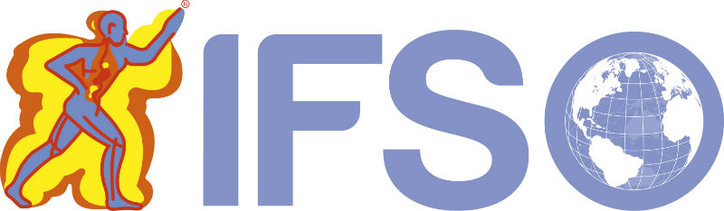 International Federation for the Surgery of Obesity and
Metabolic Disorders (IFSO)

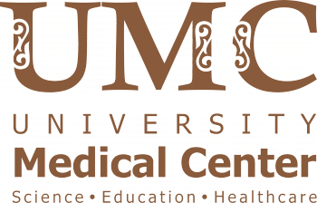 Corporate Fund “University Medical Center” (Astana,
Kazakhstan)

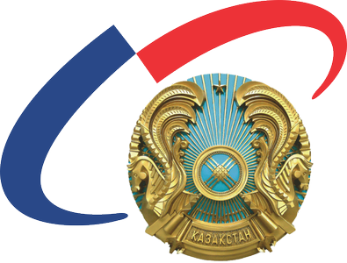 The Medical Center of the Office of the President of the
Republic of Kazakhstan (Astana, Kazakhstan)
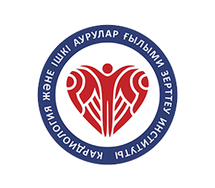The Research Institute of Cardiology and Internal Diseases
(Almaty, Kazakhstan)
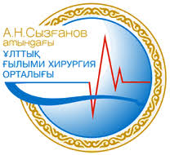
The National Scientific Center of Surgery named after
A. Syzganov (Almaty, Kazakhstan)

Astana Health Department on Astana Mayor’s

Main Sponsors:









Language of the Congress: English, Russian and Kazakh (simultaneous translation)

Accomadation:
- Astana Marriott Hotel (Adress: 2 Dostyq street, Astana, Kazakhstan, http://www.marriott.com/hotels/travel/tsemc-astana-marriott-hotel/)
- Hilton Garden Inn (Adress:15 Kabanbay Batyr Avenue, Astana, 010010, Kazakhstan, http://www.hilton.ru/hotels/hilton-garden-inn-astana/).

Congress links
Congress website:
https://kasbarimet.kz/
E-mail: bariatric.kz@gmail.com
facebook.com//events/585253275154073/
https://www.instagram.com/oralospanov/

Event Venue:
«Astana Marriott Hotel», 2 Dostyq street, Astana, Kazakhstan,
Map:
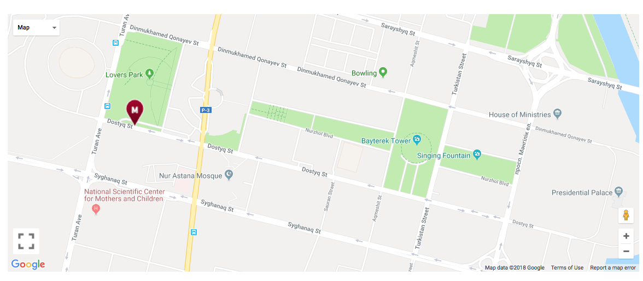
The new Astana Marriott Hotel and KaSBariMeT-2018 welcomes you to Kazakhstan's vibrant capital city with sophistication, convenience and an impeccable location. Astana Marriott Hotel located adjacent to the Bayterek Tower, in the heart of Astana's new city center; great shopping, dining and entertainment is just moments away. Intuitively designed hotel rooms and suites showcase free Wi-Fi, elegant marble bathrooms and deluxe bedding, as well as 24-hour room service and gorgeous city views. Outstanding dining options include artisanal cocktails at Lobby Bar, modern fare at Aroma Restaurant and the supremely stylish Vista Restaurant & Bar, with breathtaking views of the city of Astana. Our 5-star hotel provides the perfect venue for meetings of KaSBariMeT-2018 and social events, with light-filled spaces and full-service planning and catering. And unparalleled location places landmarks, including the Astana Opera House and the largest tent building in the world – «Khan Shatyr», well within your reach.

Greetings to the board of Congress
Dear Friends and Colleagues,
The Ι-th Kazakhstan International Congress on Bariatric and Metabolic Surgery to be hosted by the Society of Bariatric and Metabolic Surgeons of Kazakhstan. The acronym for the congress: KaSBariMeT-2018 (KazakhstanSurgicalBariatricMetabolicTreatment-2018).
KaSBariMeT-2018 is an international platform for presenting achievements on metabolic and bariatric surgery and related topics. This problem is first discussed in Central Asia. The purpose of the congress is the key lectures of leaders of bariatric and metabolic surgery and the exchanging of ideas about medical, social effects of bariatric & metabolic surgery.
KaSBariMeT-2018 will promote the spread of knowledge in a large Eurasian region, where obesity and type 2 diabetes are rapidly expanding. The Congress will be a great contribution of participants for preventing problems caused by obesity for the benefit of society.
Place of congress - Astana city. Kazakhstan Astana’s favorable location in the Centre of the Eurasian continent makes it an economically advantageous transport, communication and logistics Centre, and a natural bridge between Europe and Asia.
Today Astana, located in the heart of Eurasia, is a venue for numerous international forums, congresses and large scale international events. The Congress of Leaders of World and Traditional Religions, the Astana Economic Forum and other forums are held regularly in the city. In December 2010, the historical Summit of the Organization for Security and Co-operation in Europe took place in the capital city of Kazakhstan, after which it hosted the anniversary summits of the Shanghai Cooperation Organization and Organization of Islamic Cooperation. In early 2011, the city welcomed the participants and guests of the 7th Asian Winter Games. In 2017, Astana hosted the international specialized exhibition EXPO-2017.

Prof. Dr.Henry Buchwald
Prof. Dr. Mazhit Shaidarov
Prof. Dr. Oral Ospanov

Heads of board of Congress

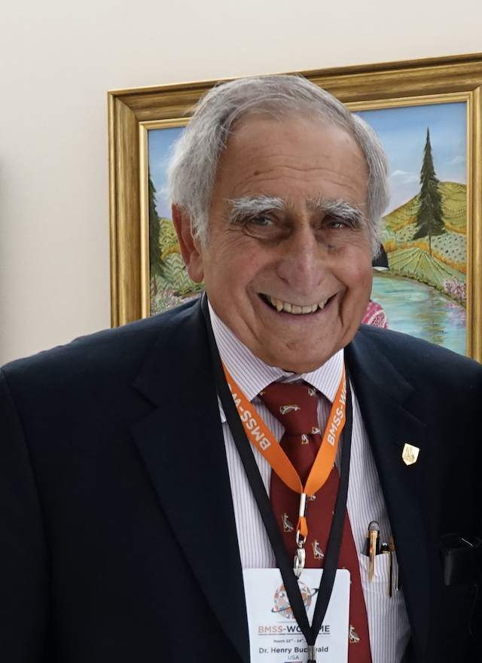 | Congress Honorary President KaSBariMeT-2018  MD, PhD, FACS, HonFRCS, Professor of Surgery and Biomedical Engineering Owen H. & Sarah Davidson Wangensteen Chair in Experimental Surgery, Emeritus University of Minnesota; President IFSO 2003-2004.  Prof.Dr.Henry Buchwald

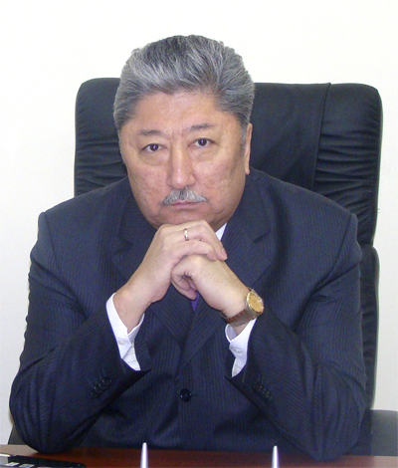 | Honorary Chairman of the Congress KaSBariMeT-2018  Rector of the Astana Medical University, (Astana, Kazakhstan)  Prof. Dr. Mazhit Shaidarov

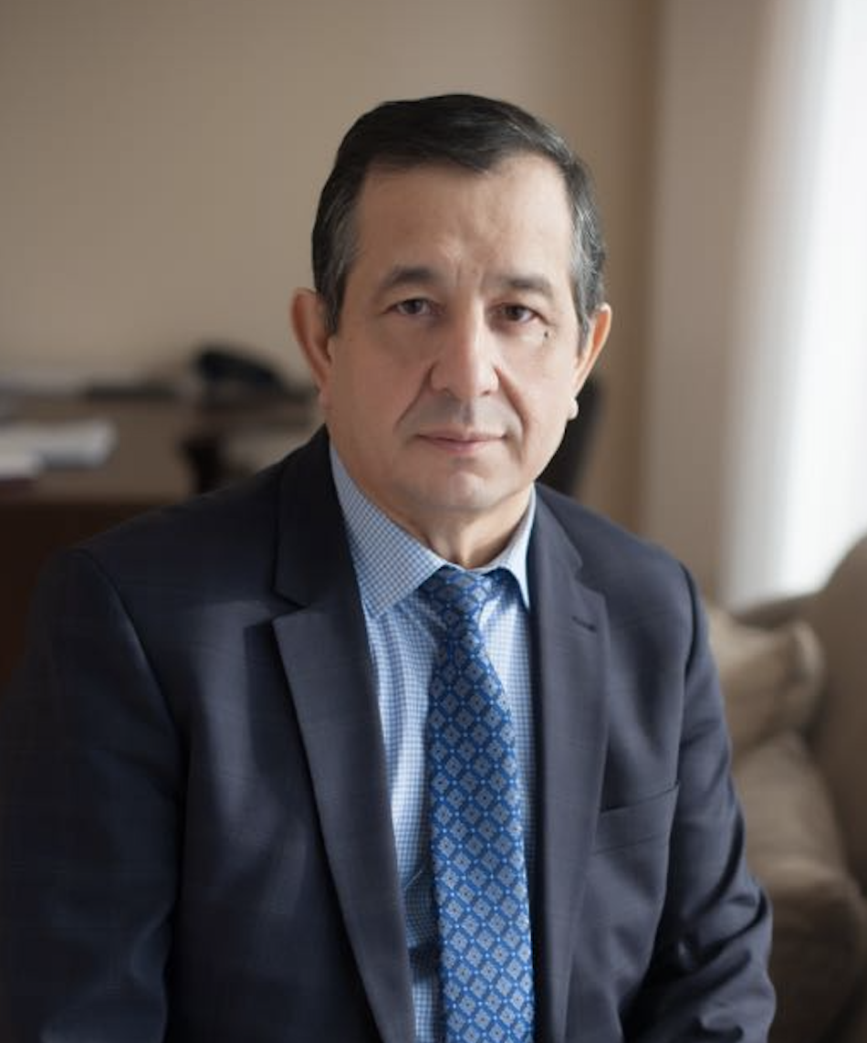 | President of the Congress KaSBariMeT-2018  Head of the Department of Laparoscopic & Bariatric Surgery of Astana Medical University, (Astana, Kazakhstan)  Prof.Dr. Oral Ospanov

Members a board of Congress
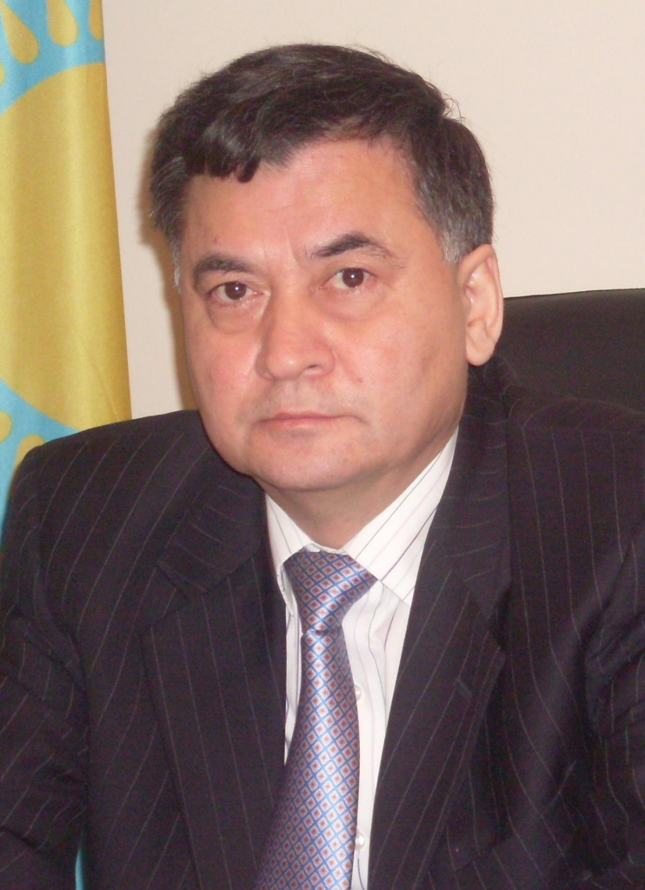 | Prof. Dr.Zhaxybaу Zhumadilov; MD. Chairman of the Board of the Corporate Fund “University Medical Center” (Astana, Kazakhstan)
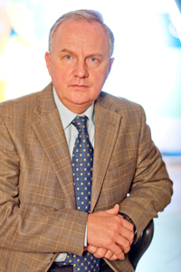 | Prof. Dr. Valeri V. Benberin, M.D., Ph.D. Head of the Medical Center of the Office of the President of the Republic of Kazakhstan
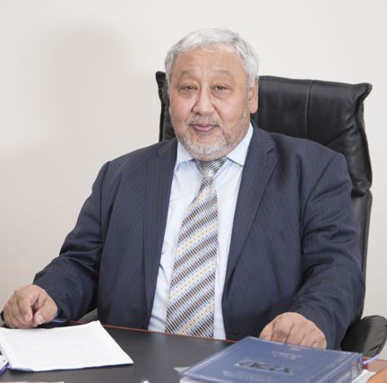 | Prof.Dr.Salim Berkinbayev; MD, Director of the Research Institute of Cardiology and Internal Diseases (Almaty, Kazakhstan)
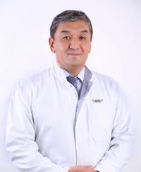 | Prof. Dr.Bulatbek Baimakhanov; MD. Chairman of the Board of the National Scientific Center of Surgery named after A. Syzganov (Almaty, Kazakhstan)
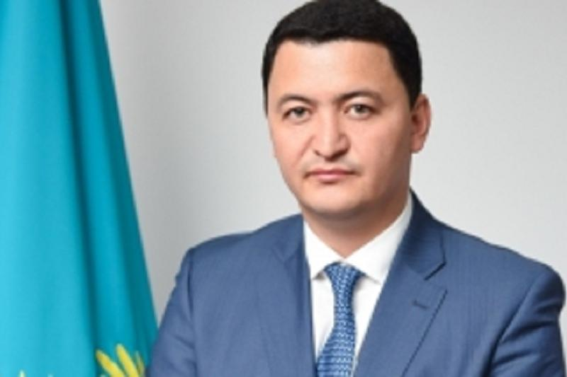 | Dr. Kamalzhan Nadyrov - MD, PhD, Head of Astana Health Department on Astana Mayor’s

International Scientific Committee of KaSBariMeT-2018

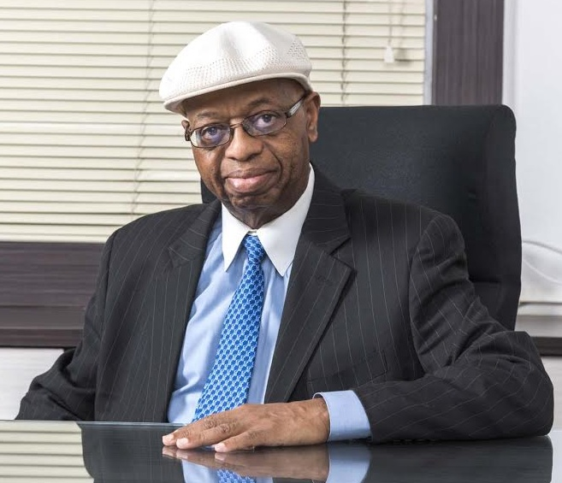 | Honorary Chairman of the International Scientific Committee of KaSBariMeT-2018  MD FACS, FACN, FICS. President IFSO 2008-2009)  Prof. Dr. Mathias Fobi
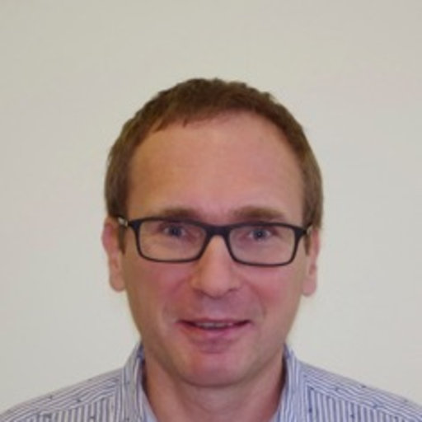 | Chairman of the International Scientific Committee of KaSBariMeT-2018  Prof.Dr.A.Maleckas (Lithuania)
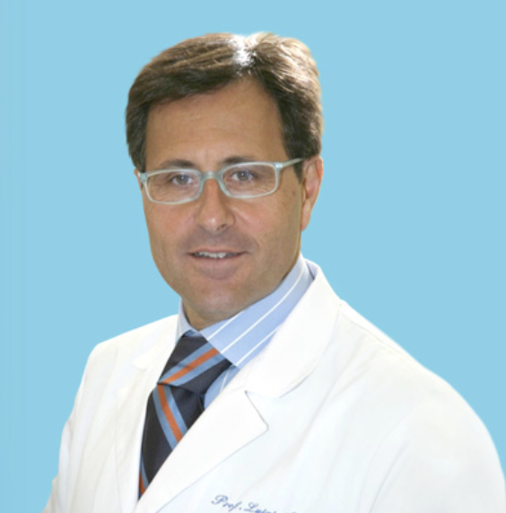 | Dr. Luige Angrisani (Italy)
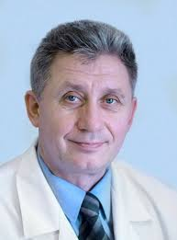 | Prof.Dr. Yury Yashkov (Russia)
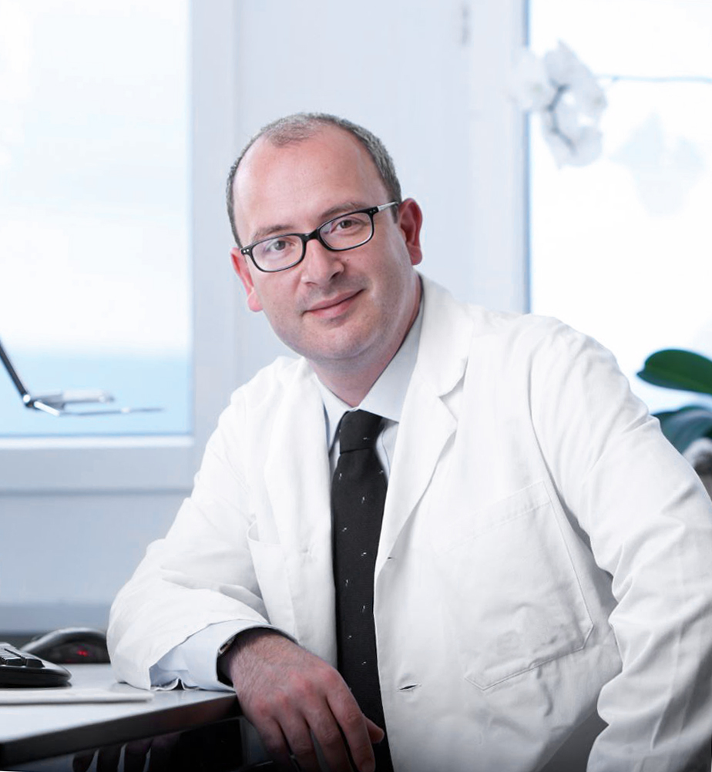 | Dr. Plamen Staikov (Germany);
 | Dr.Robert Rutledge (USA)
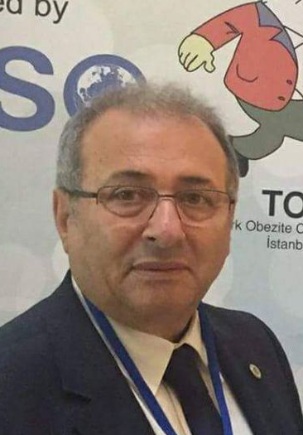 | Prof.Dr. Mustafa Taskin (Turkey)
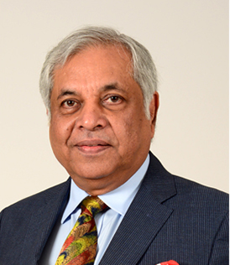 | Dr. Pradeep Chowbey (India)
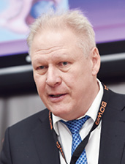 | Prof.Dr. Andriy Lavryk (Ukraine)
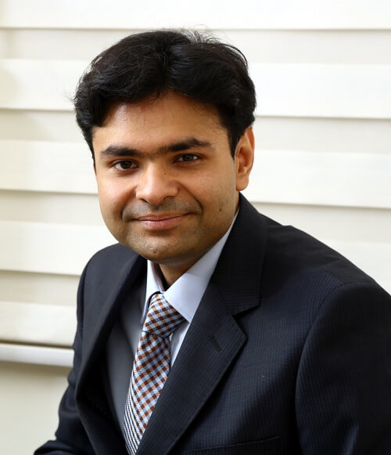 | Dr. Mohit Bhandari (India)
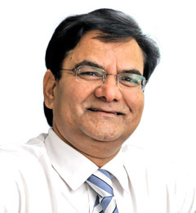 | Dr. Shrihari Dhorepatil (India)
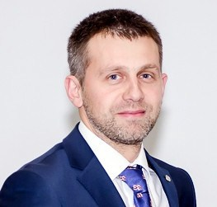 | Dr. Aleksandr Neimark (Russia);
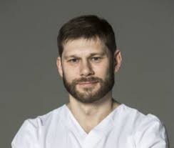 | Dr. Vladimir Samoylov (Russia)
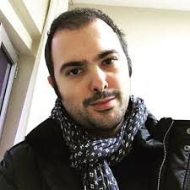 | Dr. Eren Taskin (Turkey)
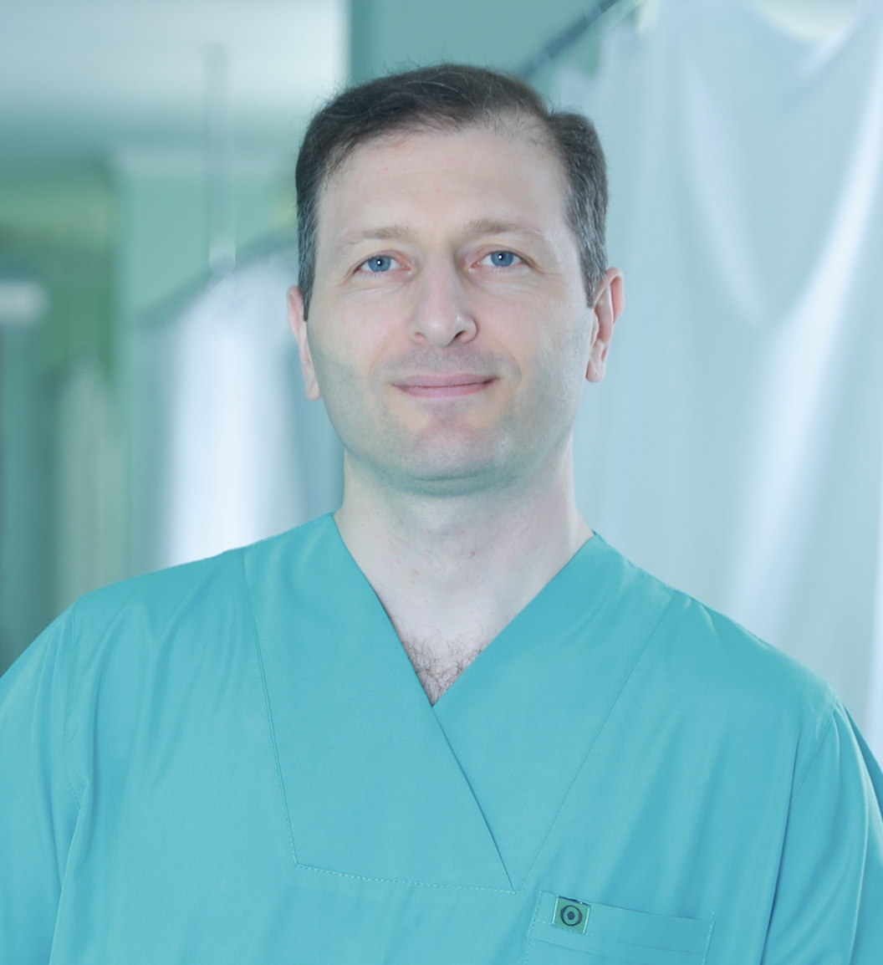 | Dr. Tariel Omerov (Azerbaijan)
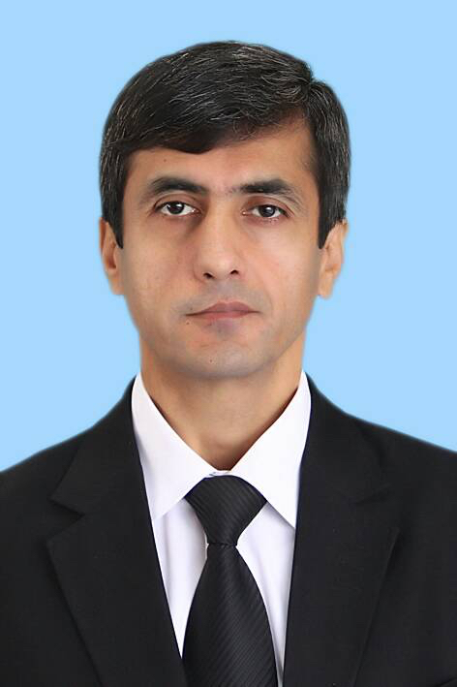 | Prof.Dr. Oktyabr Teshaev (Uzbekistan)
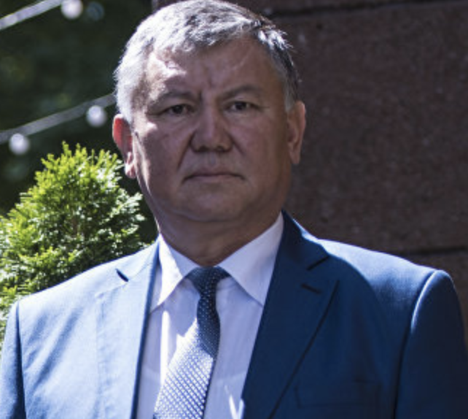 | Prof. Dr.Ernis Tilekov (Kyrgyzstan)
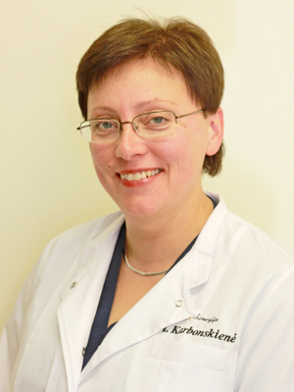 | Prof. Dr. Aurika Karbonskienė - MD, PhD, Anaesthesiology and Reanimatology Kaunas Medical University Hospital (Kaunas, Lithuania)
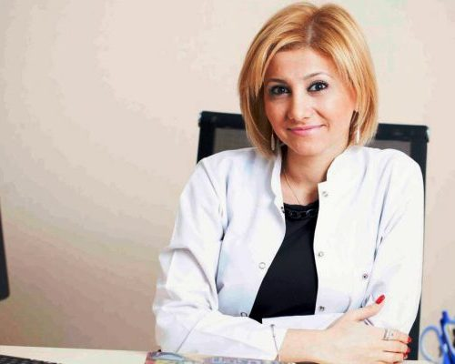 | Dr. Tutu Zeynalova (Azerbaijgan). Dietoloq

Local organizing committee (Kazakhstan)
Chairman: As.Prof. Dr. Ermek Akhmetov

Members:
Prof. Serik Tokpanov (Astana);
Prof. Vladimir Kotlobovsky (Aktobe);
Prof. Omarkhan Erganov (Karaganda);
Dr. Kanat Abildin (Kustanay);
Dr. Aygul Raisova (Almaty);
Dr. Anna Bazarova (Astana);
Dr. Gulnara Tulesheva (Astana);
Dr. Assel Khasenova (Astana);
Dr. Jenis Sergashin (Shimkent);
Dr. Samarbay Mukanov (Oral);
Dr. Askar Zhumagaliev (Taraz);
Dr. Alimgan Mukhambetov (Pavlodar);
Dr. Mereke Negemetzanov (Petropavl);
Dr. Talgat Mukantayev (Aktau);
Dr. Amangol Dyusupov (Atyrau);
Dr. Aset Elemesov (Aktobe);
Dr. Baurgan Akhmetov (Kokshetau);
Dr. Roman Fursov (Astana);
Dr. Ashkhat Bekbosynov (Astana).

Scientific program
Time | First day (04.07.2018)
08.00- 9.00 | Registration of participants in Ballroom Foyer
09.00-11.00 | Opening Ceremony and Session: A1  Bariatric & Metabolic surgery - history and current status world wide and the urgency for Kazakhstan
09.00 | Welcome speech at the Opening Ceremony (2 minutes for each):  - Dr. Elgan Birtanov Ministry of Health of the Republic of Kazakhstan, PhD (Astana, Kazakhstan) (Moderator) ;  - Prof. Dr. Mazhit Shaidarov; Rector of the Astana Medical University, Honorary Chairman of the Congress KaSBariMeT-2018 (Astana, Kazakhstan) (Moderator) ;  - Prof. Dr. Henry Buchwald; MD, PhD, FACS, HonFRCS, Professor of Surgery and Biomedical Engineering Owen H. & Sarah Davidson Wangensteen Chair in Experimental Surgery, Emeritus University of Minnesota; President IFSO 2003-2004, Congress Honorary President of KaSBariMeT-2018 (USA) (Moderator);  - Prof. Dr. Oral Ospanov; President of SBMSK, President of Congress KaSBariMeT-2018 (Astana, Kazakhstan) (Moderator);  - Prof. Dr.Mathias Fobi, MD FACS, FACN, FICS. President IFSO 2008-2009, Honorary Chairman of the International Scientific Committee of KaSBariMeT-2018 (USA/India) (Moderator);  - Prof. Dr.Zhaxybaу Zhumadilov; MD. Chairman of the Board of the Corporate Fund “University Medical Center” (Astana, Kazakhstan);  - Prof. Dr. Valeri V. Benberin, M.D., Ph.D. Head of the Medical Center of the Office of the President of the Republic of Kazakhstan;  - Prof.Dr.Salim Berkinbayev; MD, Director of the Research Institute of Cardiology and Internal Diseases (Almaty, Kazakhstan);  - Prof. Dr.Bulatbek Baimakhanov; MD. Chairman of the Board of the National Scientific Center of Surgery named after A. Syzganov (Almaty, Kazakhstan);  - Dr. Kamalzhan Nadyrov Head of Astana Health Department on Astana Mayor’s.
09.20 | Awarding Ceremony of the Honorary Professor of Medical University: rector Prof. Dr. Mazhit Shaidarov (Kazakhstan)
09.30 | Bariatric & Metabolic surgery - history and current status world wide: Professor Dr. Henry Buchwald (USA)
10.00 | Bariatric & Metabolic surgery - the urgency for Kazakhstan and the project of the national guidelines for bariatric and metabolic surgery: President of SBMSK, Prof. Dr. Oral Ospanov (Kazakhstan)
10.30 | IFSO world wide survey 2016 “Primary, Revisional and Endoluminal Procedures”: Dr.Luigi Angrisani (Italy)
10.45 | IFSO Global Registry and Kazakhstan’s data: Alexey Brovko Senior Medical Advisor Dendrite Clinical Systems (UK)
11.00-11.30 | Tea/coffee break and Press Conference Faculty for Media
11.30-13.00 | Session: A2 Metabolic Surgery  Moderators:  Dr. Henry Buchwald (USA);  Dr. Yury Yashkov (Russia);  Dr. Almantas Maleckas (Lithuania);  Dr.Mathias Fobi (USA/India);  Dr. Luige Angrisani (Italy);
11.30 | Hormonal and other physiological principles of the metabolic mechanism after bariatric surgeries for the treatment of type 2 diabetes mellitus: Dr.A. Maleckas (Lithuania)
11.45 | Metabolic syndrom physiological basics of surgical treatment: Dr. Andriy Lavryk (Ukraine)
12.00 | Effectiveness of various metabolic procedures for treatment of diabetes mellitus type2: Dr. Yury Yashkov (Russia)
12.15 | Metabolic surgery for hyperlipidemia: Dr. Henry Buchwald (USA)
12.45 | Our experience of use metabolic Surgery for treatment type 2 diabetes mellitus: Dr. Oral Ospanov (Kazakhstan)
13.00-14.00 | Lunch (Poster session)
14.00-17.00 | Session: A3 Multidisciplinary approach, Pre &Postoperative Bariatric Care and basic principles of bariatric surgery  Moderators:  Dr. Aleksandr Neimark (Russia);  Dr. Taryel Omerov (Azerbaijgan)  Dr. Shrihari Dhorepatil (India);  Dr. Andriy Lavryk (Ukraine);  Dr. Aurika Karbonskiene (Lithuania);  Dr.Ernis Tilekov (Kyrgyzstan);  Dr. O.Tyvonchuk (Ukraine)
14.00 | Multidisciplinary approach for bariatric & metabolic procedures: Dr. Aleksander Neimark (Russia)
14.15 | Indications for obesity surgery (for the European and Asian ethnic groups of Kazakhstan; Indications for Surgery with low BMI or a decrease BMI after preoperative non-surgical weight loss; indications for surgery and limitations for surgeons with extreme obesity in patients): Dr.Oral Ospanov (Kazakhstan)
14.30 | Metabolic surgery - view and opinion of an endocrinologist: Dr. Aygul Raisova (Kazakhstan)
14.45 | Type 2 diabetes mellitus and obesity: analysis of the effectiveness of modern therapeutic and surgical methods of treatment and prevention: Dr. Anna Bazarova (Kazakhstan)
15.00 | Scopinaro,s principles in modern bariatric and metabolic surgery: Dr. Andriy Lavryk (Ukraine)
15.15 | Is the distance important from the pyloric sphincter for the first stapling during the sleeve gastrectomy? Dr. Taryel Omerov (Azerbaijgan)
15.30 | Аnesthesia in bariatric surgery: Dr. Aurika Karbonskiene (Lithuania)
15.45 | Diet before and after bariatric surgery: Dr. Tutu Zeynalova (Azerbaijgan)
16.00 | Nutritional support of bariatric patients: Dr. Aleksandr Neimark (Russia)
16.15 | Optimization of the tactics of perioperative management of patients with morbid obesity in combination with the syndrome of obstructive sleep apnea: Dr. Ekaterina Orlovskaya (Russia)
16.30 | Using the BAROS questionnaire to calculate QALY before and after bariatric surgery: Dr. Assel Khassenova (Kazakhstan)
16.40 | Studying the life expectancy of patients with metabolic syndrome after weight loss: a comparative randomized clinical trial (Genomic telomere length & human life expectancy): Dr. Oral Ospanov & Dr.Kuat Oshakbaev (Kazakhstan)
16.50 | Changes in the lipid profile after laparoscopic gastric bypass: Dr. Roman Fursov (Kazakhstan)
17.00 | End of the first day and announcement

Time | Second day (05.07.2018)
09.00-11.00 | Session: A4 Standart and nonstandard types of bariatric procedures  Moderators:  Dr. Mathias Fobi (USA/India)  Dr.A.Maleckas (Lithuania)  Dr.Oral Ospanov (Kazakhstan)  Dr. Pradeep Chowbey (India);  Dr. Aleksandr Neimark (Russia);  Dr. Yuldashali Egamov (Uzbekistan)
09.00 | Types of bariatric procedures: advantages and disadvantages: Dr.Mathias Fobi (USA/India)
09.15 | Comparison of safety and effectiveness Mini-gastric bypass vs Sleeve Gastrectomy: Dr.Robert Rutledge (USA)
9.30 | Laparoscopic band-separated (steple- and steplerless) gastric bypass (Ospanov’s procedure) is better alternative in bariatric surgery for low-income countries?: Dr. Oral Ospanov
9.40 | Combined bariatric procedures based on gastric plication: Dr.Constantin Milithsa (Ukraine)
9.45 | Switch- SADI-s Procedures – Surgical Techniqe and Advances : Dr. Yury Yashkov (Russia)
10.10 | Comparison of Banding and Non-Banding Gastric Bypass: Dr.Mathias Fobi (USA/India)
10.30 | The Future of “Bariatric Surgery” Why Learn the MGB : Dr.Robert Rutledge (USA)
10.45 | Robotic single incision bariatric surgery: Dr. Mohit Bhandari (India)
11.00-11.15 | Tea/coffee break
11.15-13.00 | Session: A5 Wich bypass is better? MGB/OAGB and RYGB  Moderators:  Dr.Robert Rutledge (USA)  Dr. Plamen Staikov (Germany)  Dr. Vladimir Samoylov (Russia);  Dr.Mohit Bhandary (India);  Dr.Plamen Staikov (Germany);  Dr. Yury Yashkov (Russia);
11.15 | Key Lecture: Laparoscopic Roux en Y gastric bypass is “old” gold standard of Bariatric Surgery?: Dr. Plamen Staikov (Germany)
11.30 | Key Lecture: MGB 4 Keys 1. Mechanism of Action of the MGB, Neither Obstructive or Malabsorbtive; 2. General Surgery Comparison ± Duodenal Exclusion: Dr.Robert Rutledge (USA)
11.45 | Key Lecture: MGB 4 Keys 3. Bilio-Pancreatic Limb Length & Outcome; Linear Regression Analiysis; 4 MGB for “Thin Diabetics”: Dr.Robert Rutledge (USA)
12.00 | Laparoscopic MGB/OAGB for super-super obesity: Dr. Mohit Bhandari (India)
12.15 | The advantages of MGB-OAGB - the maximum opportunities for revisions and conversion to normal anatomy: Vladimir Samoylov (Russia)
12.30 | Comparative analysis of the bariatric and metabolic effects of Roux-en-Y gastric bypass and mini gastric bypass: Dr. V.V. Moskalenko, Dr. O.S. Tyvonchuk (Ukraine)
12.45 | Metabolic Roux-en-Y gastric bypass: Dr.A. Maleckas (Lithuania)
13.00-14.00 | Lunch/Videomarathon (How I do it)
14.00-16.30 | Session: A6 Prevention, Management of Complication and Revisional Surgery after Bariatric Surgery  Moderators:  Dr.Henry Buchwald (USA)  Dr. Andriy Lavryk (Ukraine)  Dr. Pradeep Chowbey (India);  Dr. Tariel Omerov (Azerbaijan);  Dr.Mustafa Taskin (Turkey)  Dr. Oktyabr Teshaev (Uzbekistan)
14.00 | Key lecture: the prevention of complications for bariatric surgery: Dr.Henry Buchwald(USA)
14.30 | Complications in bariatric and metabolic Surgery: Dr. Andriy Lavryk (Ukraine)
14.45 | Diagnosis and management of complication in bariatric surgery Dr. Pradeep Chowbey (India)
15.00 | Justification of re-operative bariatric surgery: Dr. Pradeep Chowbey (India)
15.15 | Management of Complication in Bariatric Surgery: Dr.Med.Roman Koch (Germany)
15.30 | Side to side jejune-ileal anastomosis as a revisional procedure in long term failed sleeve gastrectomy for metabolic control. Dr. Eren Taskin (Turkey)
15.45 | Revision of MGB and Side to side jejunoileal anastomosis to normal anatomy incase of excess weight loss and malnutrition or chronic pain. Dr. Eren Taskin (Turkey)
16.00 | MGB: Surgical Technique: Technical Errors and Prevention: Dr.Robert Rutledge (USA)
16.15 | Complications of gastroenteroanastomosis after bypass and revisional surgery: Dr. Maria Solovieva (Russia)
16.20 | Secondary operations after Swich and Sadi-s: Dr. Yury Yashkov (Russia)
16.30-16.40 | Tea/coffee break
16.40-17.00 | Session: A7 Discussion and Acceptance Resolution (Recommendation, Guidelines) Congress of “KaSBariMeT-2018” for the Ministry of Health of the Republic of Kazakhstan  Experts:  Prof. Henry Buchwald (USA);  Prof. Mathias Fobi (USA/India);  Dr. Luige Angrisani (Italy);  Dr.Robert Rutledge (USA);  Prof.Dr.A.Maleckas (Lithuania);  Prof.Dr. Mustafa Taskin (Turkey);  Prof.Dr. Yury Yashkov (Russia);  Dr. Pradeep Chowbey (India);  Prof.Dr. Andriy Lavryk (Ukraine);  Dr. Plamen Staikov (Germany);  Prof. Dr.Bolatbek Baymakhanov (Kazakhstan);  Dr. Shrihari Dhorepatil (India);  Prof. Salim Berkinbayev (Kazakhstan);  Dr. Mohit Bhandari (India);  Prof. Zhaxybaу Zhumadilov (Kazakhstan);  Prof. Aleksandr Neimark (Russia);  Prof. Vladimir Samoylov (Russia);  Prof. Valeri V. Benberin (Kazakhstan);  Dr. Eren Taskin (Turkey);  Prof. Ernis Tilekov (Kyrgyzstan);  Prof. Tariel Omerov (Azerbaijan);  Prof. Oktyabr Teshaev (Uzbekistan);  Prof. Aurika Karbonskiene (Lithuania);  Dr. Aygul Raisova (Kazakhstan);  Dr. Anna Bazarova (Kazakhstan);  Prof. Oral Ospanov (Kazakhstan).
17.00-17.30 | Closing Ceremony Moderators:  Prof. Dr. Mazhit Shaidarov (Kazakhstan);  Prof. Bolatbek Baymakhanov (Kazakhstan);  Prof. Salim Berkinbayev (Kazakhstan);  Prof. Zhaxybaу Zhumadilov (Kazakhstan);  Prof. Valeri V. Benberin (Kazakhstan);  Prof. Oral Ospanov (Kazakhstan).

